ACCOMMODATION BOOKING FORM
Bridging Gaps Conference
4th to 5th of July 2016
Mr/Mrs/Ms:
First name:
Surname:
SPG Number:
Address
Country:
Telephone:
Fax:
E-mail:

ROOM TYPE | OCCUPANCY | RATE PER NIGHT | MARK WITH A X
Classic room | Single occupancy | € 129
Classic room | Double occupancy | € 144

Price includes: 10% VAT, Breakfast, Internet, daily bottled water, Gym access Not included: Tourism tax of 0,72€ per person per day

ROOM RESERVATION:
Reservations are subject to hotel availability at any time. In order to request a reservation, please return this booking form fully filled out by EMAIL to sales@fourpointsbarcelona.com
ARRIVAL DATE: Time: (check in time from 3pm)
DEPARTURE DATE: Time: (check out before 12 pm)
Bookings apart from the main nights (prior and post to the event dates), are subject to hotel availability.
PAYMENT DETAILS:
Please find the applicable payment instructions outlined below in this document.
We need a valid credit card in order to guarantee the reservation and process the payment as outlined below:
Name of cardholder:
Card type:
Card number
Expiry Date:

Signature:

For terms & conditions please review page 2 of this document

TERMS & CONDITIONS:
Cancellation policy:
Cancellations until May 4th, 2016 Free of charge
Cancellations between May 5th and June 4th A fee equal to 50% of the anticipated stay will be charged on the given credit card.
Cancellations as of June 5th A fee equal to the entire anticipated stay will be charged on the given credit card.
In case of no-Shows or cancellations out of out of the agreed cancellation policy, the full anticipated stay will be charged.
For cancellations at any time, please contact sales@fourpointsbarcelona.com
PAYMENT CONDITIONS:
For reservations done until May 4th 2016 , the hotel will charge a deposit of the first night’s stay on each respective credit card as deposit payment and guarantee of the booking on May 4th 2016.
For reservations made after May 5th , 2016 (subject to availability), the hotel will charge a deposit of the first night’s stay on the day of the reservation.
Payment of the pending amount will be done on check-in.
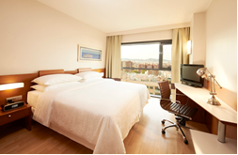
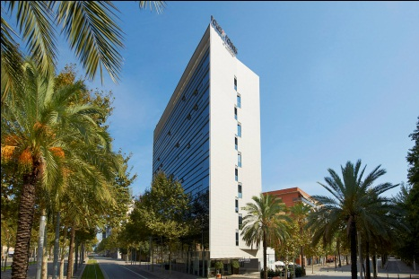

More info “how to get there”: www.fourpointsbarcelonadiagonal.es

